Sew Much More
Witch/Wizard Hat
Wendy Kleman
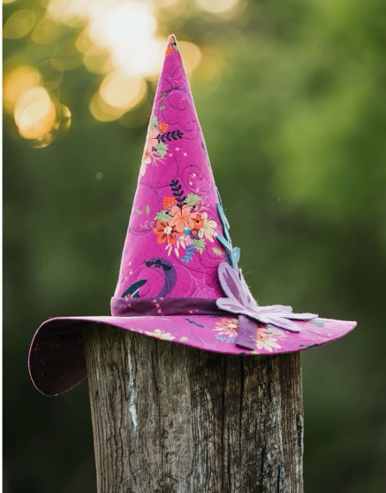

Have fun making a hat for a witch or a wizard. You are the designer so it can be taller, have a wider brim or ? It will fit your head perfectly. Be ready for your next Wicked party appearance or cosplay event.

Supplies
¾ yd fabric for exterior
¾ yd for lining
¾ Décor-Bond by Pellon
If quilting the fabric you will also need ¾ yd of muslin and batting (Hobbs Heirloom is what I used) If you are quilting your fabric you should quilt the ¾ yd piece before class.

Sewing Machine
Scisssors
Rotary Cutter
Pins
Thread
Pencil
6” by 28” or 24” ruler

If you have any questions about the class or what to bring please contact Wendy Kleman at the store: 262-547-7774

Class Policies
- Classes require a minimum of 4 students. If the minimum is not reached 2 weeks before class, it will be cancelled and students will receive a full refund.
- If you have registered for a class and must cancel, please contact us ASAP. You must cancel at least two (2) weeks in advance to receive a refund or credit. No credit for no-shows.
- In deference to those with sensitivities, we ask that you refrain from wearing perfume or other scented products
- We would appreciate it if you purchase your supplies at Sew Much More. We will be happy to assist you in gathering all the necessary materials – and give you a 15% discount!

