Christmas Tree Skirt
Wendy Kleman Instructor
Christmas Tree Skirt
Sew Much More
2026
Wendy Kleman

Supplies
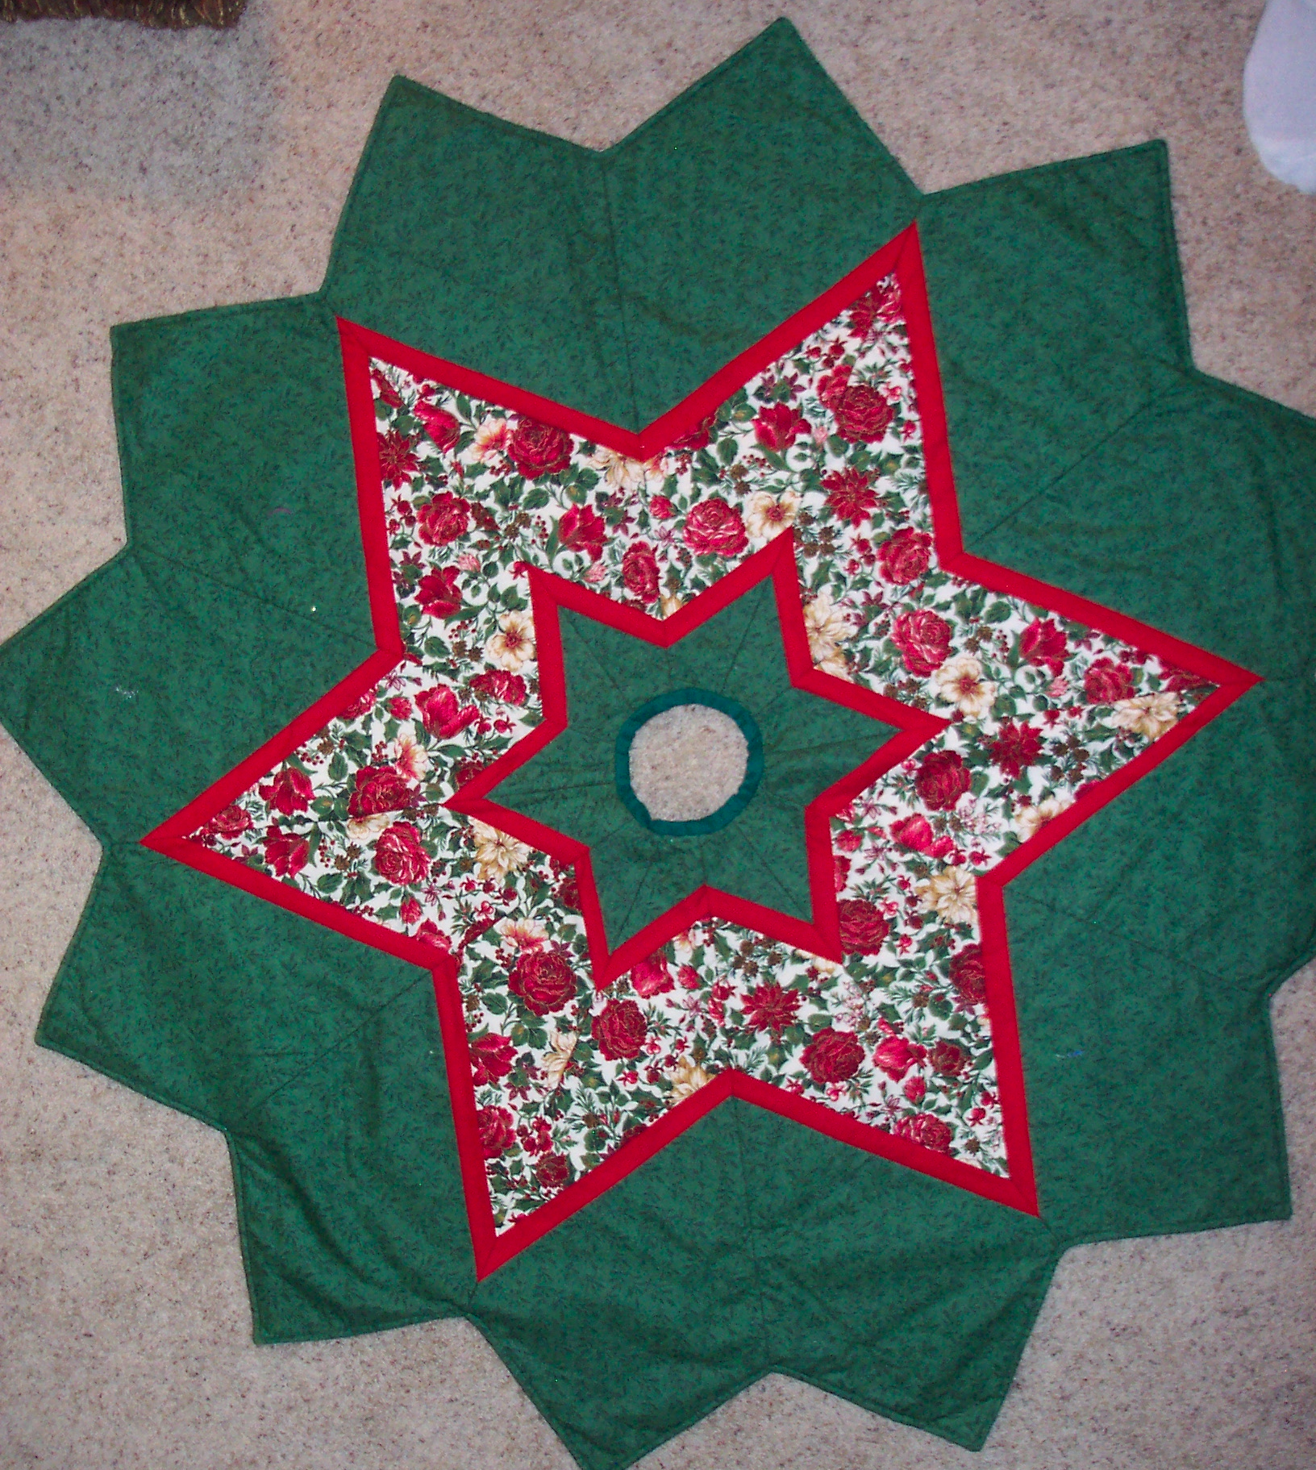
Fabric
- Background Fabric (I used a green, all over print) 2 ½ yds
- Christmas print (this is a good place to showcase a pretty Christmas print) 1 yd
- Accent color (I used red) ½ yd
- Backing 3 ¼ yd (I used muslin)
Warm and Natural Batting: 4 pieces that are about 32” by 45”
Neutral cotton thread
Walking foot for you sewing machine
Rotary cutter, 6” by 24” rectangular ruler and cutting mat
Scissors
Masking tape
Fixion Pen
Sewing Machine

If you have time before class and you are comfortable using a rotary cutter,

Cut:
- Background Fabric: 8 strips that are the width of the fabric (WOF) and 10 ½ inches wide
- Christmas print: 4 strips that are the WOF by 5 ½”
- Accent color: 8 strips that are the WOF by 1 ½”

This is a fast and easy tree skirt, that can be made in a day. The top is sewn and quilted at the same time. The edges can be pointed or rounded. I don’t leave a side open because I use it for an artificial tree, but you can certainly leave a slit to get around a real tree. I also use it as a round table cloth and put a doily over the center..so one year it is a tree skirt and one year a table topper!

Looking forward to seeing you!
Email me with any questions or stop by the store. wendy@sewmuchmorewi.com

