T-Shirt Class
Instructor Wendy Kleman
Sew Much More
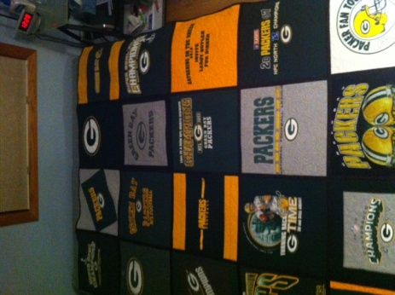
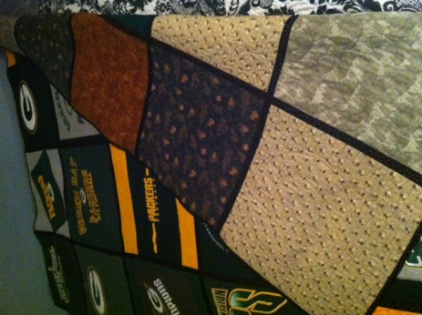
This is a great way to make a t-shirt quilt! No need to fuse interfacing to the back! It is also reversible and quilt as you go. What more could a quilter ask for! You could make it 4 by 5
blocks or 3 by 4 blocks.
Supplies:
- 12-20, cotton t-shirts washed without fabric softener (My quilt has 20 blocks and it covers the top of a Queen size bed. I used the backs, sleeves, and some child size shirts appliquéd onto a plain t-shirt) No need to cut them apart we will talk about doing that in class.
- Queen size Fusible Hobbs Heirloom batting. It must be this batting that is fusible on both sides. Precut to 16.5" squares. (Either 12 or 20 depending on the size you are making) Frank's Sewing Center carries this batting. It can also be found on the internet. You must use this batting for this technique. If you are uncomfortable cutting this ad wants some tips on doing it, wait until class to cut the batting.
- Sashing and binding: 2 ¼ yards of cotton fabric
- Backing fabric: A variety of 16.5" squares. I used 20 flannel squares. Cotton fabric could be used also. Do not use fleece (after making one you can try fleece for the backing but not for the first time. If using all the same fabric buy 4.75 yards.
- A 16.5 inch square ruler and a 15" square ruler. I will have a couple to use in class if you do not have them. You could go to a hardware store and have them cut these sizes from Plexiglas. I will also show you how to use the June Tailor Shape Cut to cut out the 16.5” squares if you own one of those.
- Rotary cutter. With the thickness of what we are working on a 60mm cutter would work better.
- Thread for machine quilting. Thread for piecing that matches your sashing color.
- Sewing machine with regular foot, walking foot and darning foot. Please know how to use these on your machine or bring your manual.
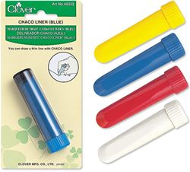
- Chaco Liner, or sliver of soap for marking
- Basic sewing supplies

Precut your batting and backing into 16.5" squares. We will cut the shirts in class. Bring batting and backing and machine to class. During class I hope that you can get two or three shirts layered and ready to quilt at home. You probably do not need to bring a machine to th first class. . The second class will be how to put theses quilted blocks together
If you are working with smaller t-shirts, please email me. You cut them out at 14" and then cut them down to 12.5"

Questions? Contact Wendy at the store 262-547-7774 or wendy@sewmuchmorewi.com

