Sew Much More
Cosplay
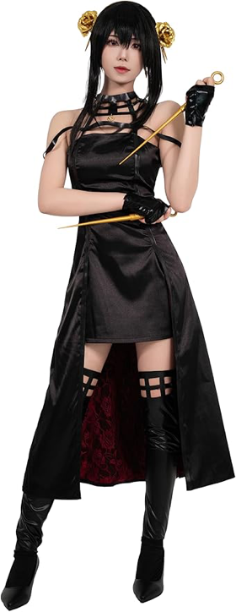
Wendy Kleman

Make your own costumes and alter ready-made ones Come to Sew Much More and learn about basic sewing skills. We will cover some sewing machine skills, hand sewing, as well as ways to alter garments using paints, foam, embroidery and more.

Supplies
Bring your own pattern and fabric or ready made costume and we will work on it together
Sewing Machine
Scisssors for paper and fabric
Rotary Cutter
Pins
Thread
Pencil
6” by 28” or 24” ruler

If you have any questions about the class or what to bring please contact Wendy Kleman at the store: 262-547-7774

Class Policies
- Classes require a minimum of 4 students. If the minimum is not reached 2 weeks before class, it will be cancelled and students will receive a full refund.
- If you have registered for a class and must cancel, please contact us ASAP. You must cancel at least two (2) weeks in advance to receive a refund or credit. No credit for no-shows.
- In deference to those with sensitivities, we ask that you refrain from wearing perfume or other scented products
- We would appreciate it if you purchase your supplies at Sew Much More. We will be happy to assist you in gathering all the necessary materials – and give you a 15% discount!

