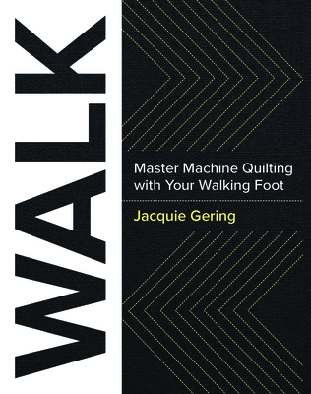**Sew Much More**

**Walk this Way**

**Wendy Kleman**

**2025**

**Supplies**

* 4, 20” square cotton quilt sandwiches of a light solid color (Hobbs Fusible batting recommended)
* Walking foot (With guide if you have it)
* Sewing machine in good working order with a new Microtex needle and several filled bobbin
* Frixion Pen
* Aurifil thread in a medium to dark color. Grey is always a good choice
* 12 ½” quilting ruler
* The WALK book
* Paper and pen
* A quilt top you need ideas on how to quilt so the class can brain storm
* Bring a snack or bag lunch

If you have any questions about the class or what to bring please contact Wendy Kleman at the store: 262-547-7774

# Class Policies

* Classes require a minimum of 4 students. If the minimum is not reached 2 weeks before class, it will be cancelled and students will receive a full refund.
* If you have registered for a class and must cancel, please contact us ASAP. You must cancel at least two (2) weeks in advance to receive a refund or credit. No credit for no-shows.
* In deference to those with sensitivities, we ask that you refrain from wearing perfume or other scented products
* We would appreciate it if you purchase your supplies at Sew Much More. We will be happy to assist you in gathering all the necessary materials – and give you a 15% discount!