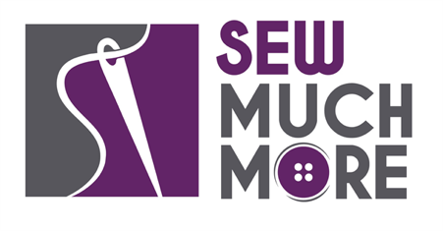
Sew Much More
2140 W St Paul Ave
Waukesha 262-547-7774
Supply List for Upcycled Sweatshirt
Wendy Kleman
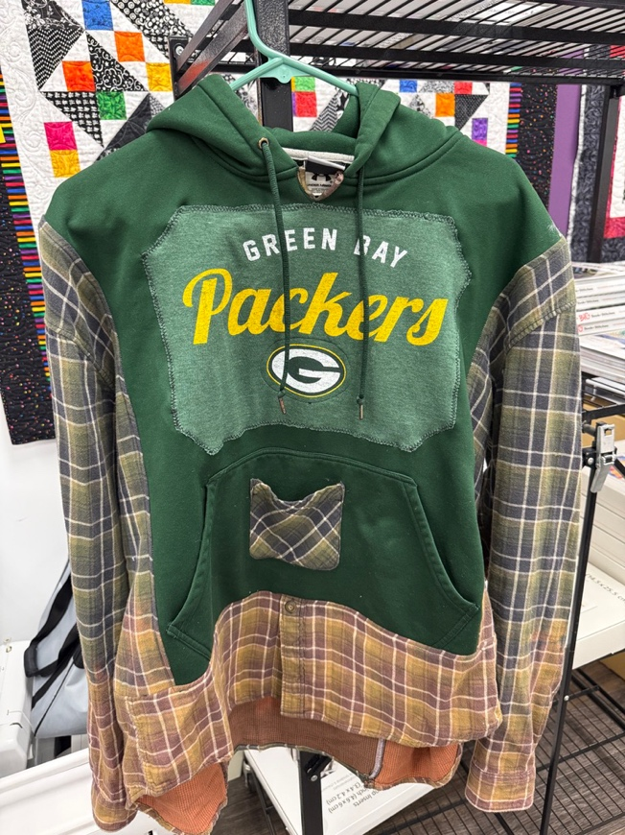

Supplies for Class
Find a t-shirt you love, A sweatshirt (with or without a hood and pocket. No Zipper) the color should match the color of the t-shirt and a flannel shirt. Sizes are not critical. The t-shirt can be anysize. The sweatshirt should be about your size. The flannel shirt should have sleeves that are long enough to fit you.

1 yd of Heat and Bond Stretch adhesive web

Sewing machine in good working order
Universal Machine needle 80/12 or 90/14
Glass head straight pins or heat-resistant pins are great
Rotary cutter with sharp blade
All purpose thread to match sweatshirt color
Seam ripper, small sharp point scissors, large scissors

Sewing Machine in good working order. Always a good idea to clean, oil, put a new needle in before class. Bring the manual for the machine if you are not familiar with all aspects of the machine.
The classroom has large cutting mats, irons and ironing boards if you do not want to bring your own
If you have any questions about the class or what to bring, please contact Wendy Kleman at the Waukesha store: 262-547-7774

Class Policies
- Classes require a minimum of 4 students. If the minimum is not reached 2 weeks before class, it will be cancelled, and students will receive a full refund.
- If you have registered for a class and must cancel, please contact us ASAP. You must cancel at least two (2) weeks in advance to receive a refund or credit. No credit for no-shows.
- In deference to those with sensitivities, we ask that you refrain from wearing perfume or other scented products
- We would appreciate it if you purchased your supplies at Sew Much More. We will be happy to assist you in gathering all the necessary materials – and give you a 15% discount!

