Supply List for Little Fairies

I will supply all the items that you will the items to make the Fairy.

Only items that you need to bring:
Scissors
Needles
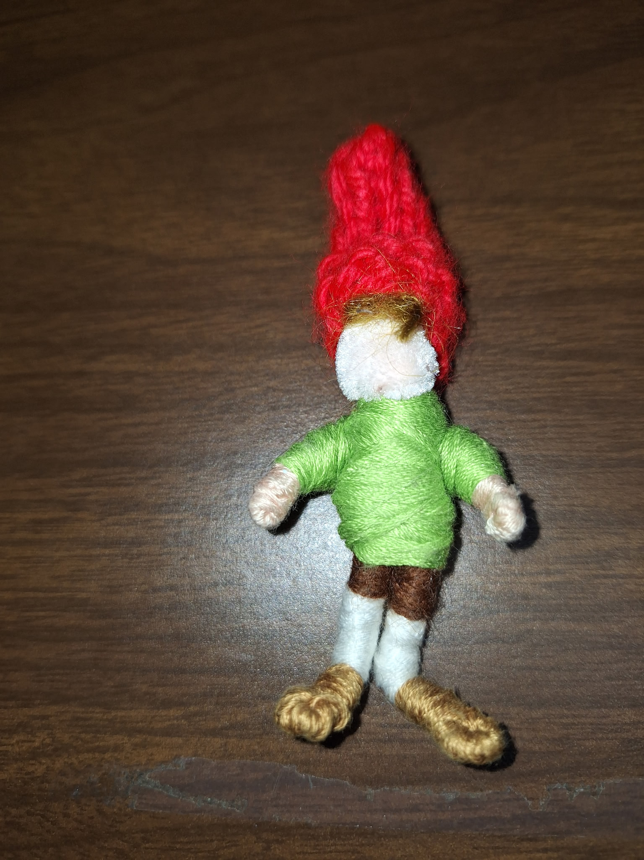
Thread (variety of colors)

