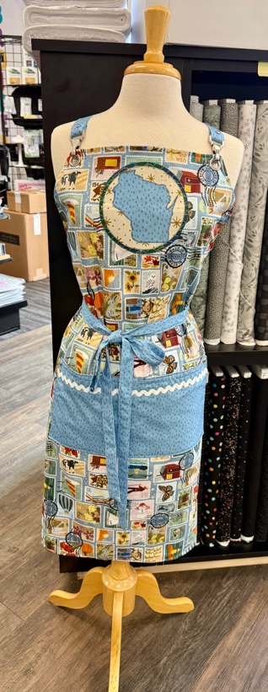
Prym Dritz Reversable Apron
Sew Much More
Wendy Kleman
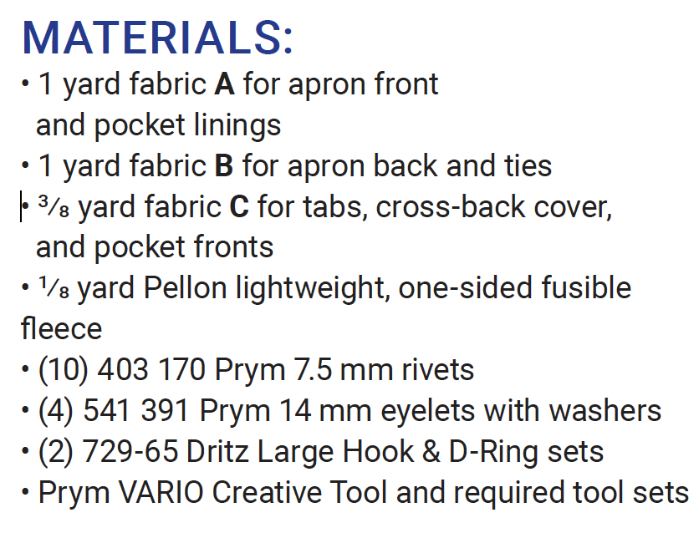
Basic Sewing Supplies (Pins, needles, scissors, rotary cutter, thread, seam ripper, rulers Add specifics if needed) Sewing Machine in good working order. Always a good idea to clean, oil, put a new needle in before class. Bring the manual for the machine if you are not familiar with all aspects of the machine or if the techniques in class are new to you.
The cost of the class includes your fabric. You can come and pick out the fabric of your choice. We have some of the Shop Hop fabric set aside for the class if you are interested in replicating the one Wendy made. Let the staff know when you come it to get your fabric for the class. (this is on a first come first serve basis) We will also have the Accuquilt die that is the State of Wisconsin available for you to use during class. We will have the rivets and D-Rings and eyelets available in class You will have access to our Prym VARIO tool. (You can then decide if you want to purchase one)
If you have any questions about the class or what to bring please contact Wendy Kleman at the store: 262-547-7774

Class Policies
- Classes require a minimum of 4 students. If the minimum is not reached 2 weeks before class, it will be cancelled and students will receive a full refund.
- If you have registered for a class and must cancel, please contact us ASAP. You must cancel at least two (2) weeks in advance to receive a refund or credit. No credit for no-shows.
- In deference to those with sensitivities, we ask that you refrain from wearing perfume or other scented products
- We would appreciate it if you purchase your supplies at Sew Much More. We will be happy to assist you in gathering all the necessary materials – and give you a 15% discount!

- Class Policies
- Classes require a minimum of 4 students. If the minimum is not reached 2 weeks before class, it will be cancelled and students will receive a full refund.
- If you have registered for a class and must cancel, please contact us ASAP. You must cancel at least two (2) weeks in advance to receive a refund or credit. No credit for no-shows.
- In deference to those with sensitivities, we ask that you refrain from wearing perfume or other scented products
- We would appreciate it if you purchase your supplies at Sew Much More. We will be happy to assist you in gathering all the necessary materials – and give you a 15% discount!

