**Sew Much More**

**2140 W St Paul Ave**

**Waukesha 262-547-7774**

**Supply List for Free Motion Quilting**

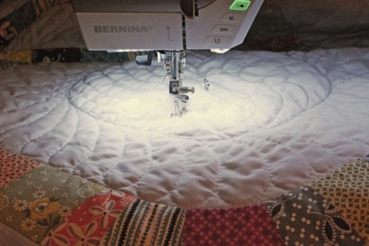

Wendy Kleman

This will be a unique opportunity for people who want to learn more about free motion quilting. We will practice different free motion patterns in the morning on quilt sandwiches and in the afternoon we will move to the quilt studio and try out the Bernina sit down machines and the longarms for free motion

**Supplies for Class**

4, 20” quilt sandwiches (Fabric, batting, backing) safety pinned together

Cotton thread in your choice of color

A wound bobbin that matches

Quilting gloves

Microtex #80/12 needle

Thread snips or scissors

**Sewing Machine** in good working order. Always a good idea to clean, and oil. Bring the manual for the machine if you are not familiar with all aspects of the machine. Know how to drop the feed dogs. Bring the free motion foot. Bring your BSR if you have it for your Bernina machine

In the longarm studio, we will provide fabric on the longarms for you to use. For the Sit down machines you will use one of your sandwiches.

Please bring a bag lunch

If you have any questions about the class or what to bring please contact Wendy Rieves, [Wendy@sewmuchmorewi.com](mailto:Wendy@sewmuchmorewi.com), 262-547-7774

# Class Policies

* Classes require a minimum of 4 students. If the minimum is not reached 2 weeks before class, it will be cancelled and students will receive a full refund.
* If you have registered for a class and must cancel, please contact us ASAP. You must cancel at least two (2) weeks in advance to receive a refund or credit. No credit for no-shows.
* In deference to those with sensitivities, we ask that you refrain from wearing perfume or other scented products
* We would appreciate it if you purchase your supplies at Sew Much More. We will be happy to assist you in gathering all the necessary materials – and give you a 15% discount!