Crazy Christmas Tree Table Runner Class Supply List
Rose Mary Huber Pauls

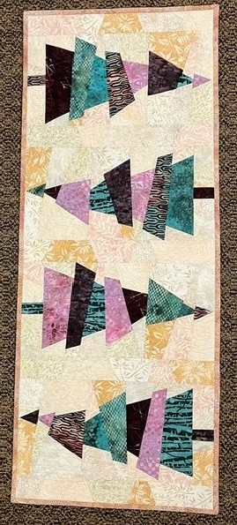

Pattern: Cut Loose Press Crazy Christmas Trees

Fabrics:
8 colored 8” x 8” squares of different colors for trees.
8 light 11” x 14” squares for background
1 ½ yards backing and binding.

Class Supplies:
Sewing machine in good working order
¼” foot
Rotary Cutter (mats will be available for use in class)
Creative Grids Spider Web Quilt ruler
Quilt ruler 6 ½ x 18” or larger
Neutral colored cotton thread
1 full bobbin wound with the neutral thread
Pins
Quilt Clips
Fabric Marker or chalk marker

Things to do before class:

Press fabrics. Using Best Press fabric starch alternative is recommended.

Questions: contact Rose Mary rmpsew@hotmail.com

