**Button Heart**

**Sew Much More**

**Wendy Kleman**

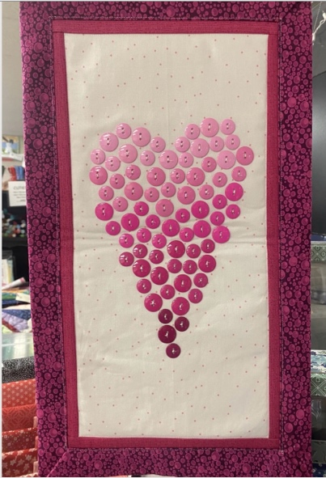

Thank you for signing up for the Button Tree class Finishes about 12” by 21”

We have the kits all ready for you.

The kit includes 1 fat quarter of background

Inner border strips

Outer border and backing

Craft Fuse

Light weight batting

Pattern

Buttons

If you have time please do some of the assembly before class. Do steps 1-3.  Remember you can rent time on the sit down Bernina machines, if you would like to try free motion with a stitch regulator.  The buttons go on at the end as well as the backing and final border  We will do all this in class. If you are uncomfortable working on the top, just wait until class and it will all be good.

Please bring Basic Sewing Supplies, a foot to sew on buttons if you have one, red thread and thread to assemble the wallhanging

We have extra button kits if you want to make a second one

If you know you want a hanger please order one at the front desk at the store. They are about $20.

If you have any questions about the class or what to bring please contact Wendy Kleman at the store: 262-547-7774

# Class Policies

* Classes require a minimum of 4 students. If the minimum is not reached 2 weeks before class, it will be cancelled and students will receive a full refund.
* If you have registered for a class and must cancel, please contact us ASAP. You must cancel at least two (2) weeks in advance to receive a refund or credit. No credit for no-shows.
* In deference to those with sensitivities, we ask that you refrain from wearing perfume or other scented products
* We would appreciate it if you purchase your supplies at Sew Much More. We will be happy to assist you in gathering all the necessary materials – and give you a 15% discount!