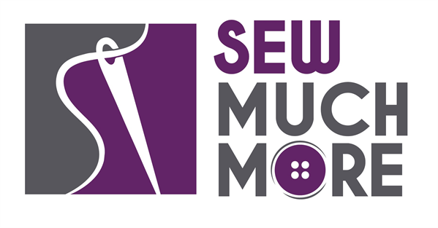
Sew Much More
2140 W St Paul Ave
Waukesha 262-547-7774
Supply List for Beginning Sewing
Lynne Thomas
Supplies for Class

Sewing Machine Owner's Manual
Bobbin for sewing machine
Fabric Scissors/Shears – should only be used to cut fabric
Seam Ripper
Straight Pins (I like 1 3/4” with glass heads)
Sewing Machine Needles – 80/12 or 90/14
Thread to match fabric
Rotary Cutter (45mm is a goodchoice)
Quilting Ruler – 6 X 24 is a good size

For the Pillowcase
3/4 yard, NON-Directional fabric (pillowcase body)
1/4 yard fabric (cuff)
For the Market Bag –
1 yard, NON-Directional fabric

Basic Sewing Supplies – See above.

Sewing Machine in good working order. Always a good idea to clean, oil, put a new needle in before class. Bring the manual for the machine if you are not familiar with all aspects of the machine.

The classroom has large cutting mats, irons and ironing boards if you do not want to bring your own. For an all day, class you might want to pack a lunch (Aldi and Le Gong restaurant are in our strip mall as an alternative)

If you have any questions about the class or what to bring please contact Lynne Thomas lawickthomas@yahoo.com or 414.748.1550

Class Policies
- Classes require a minimum of 4 students. If the minimum is not reached 2 weeks before class, it will be cancelled and students will receive a full refund.
- If you have registered for a class and must cancel, please contact us ASAP. You must cancel at least two (2) weeks in advance to receive a refund or credit. No credit for no-shows.
- In deference to those with sensitivities, we ask that you refrain from wearing perfume or other scented products
- We would appreciate it if you purchase your supplies at Sew Much More. We will be happy to assist you in gathering all the necessary materials – and give you a 15% discount!

