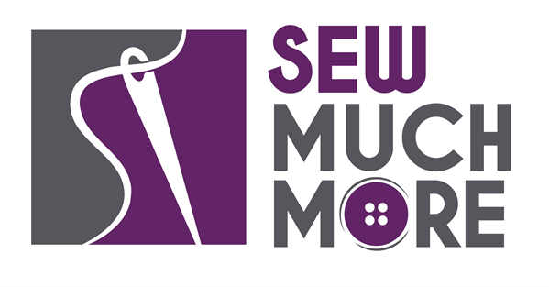
Sew Much More
2140 W St Paul Ave
Waukesha 262-547-7774
Supply List for Beginning Sewing - Skill Building
Instructor: Lynne Thomas

**School of Sewing book by Shea Henderson is required.

Week One - Microwave Cozy - Darts
2 - 10 inch pieces of ALL COTTON fabric
2 - Pieces of ALL COTTON batting such as “Wrap & Zap”
100% cotton thread

Week Two - Apron - Straps
1 yard of washable home decor fabric for apron body
½ yard for pocket and strings
Fabric marking tool
Safety pin
Matching thread

Week Three - Drawstring Backpack - Casings
½ yard for the exterior
½ yard for the lining
¼ yard for the drawstrings
Fabric marking tool
Safety pin
Matching thread

Week Four - Zipper Pouch - Zippers
¼ yard or 1 fat quarter for exterior
¼ yard or 1 fat quarter for interior
½ yard fusible interfacing ( I recommend Pellon SF 101 Shape Flex)
9” all-purpose zipper
Zipper presser foot for your sewing machine
Fabric marking tool
Matching thread

Basic Sewing Supplies – Scissors, seam ripper, pins, marking implement i.e. Frixion pen and ruler

Sewing Machine in good working order. It is always a good idea to clean, oil and to put a new needle in your machine before class. Bring the manual for the machine if you are not familiar with all aspects of the machine.

**It is also possible to use one of Sew Much More’s classroom sewing machines. Please indicate this when you register.

The classroom has large cutting mats, irons and ironing boards if you do not want to bring your own. For an all day class you might want to pack a lunch. (Aldi and Le Gong restaurant are in our strip mall as an alternative)

If you have any questions about the class or what to bring please contact Lynne Thomas, 414.748.1550 or lawickthomas@yahoo.com

Class Policies
- Classes require a minimum of 4 students. If the minimum is not reached 2 weeks before class, it will be cancelled and students will receive a full refund.
- If you have registered for a class and must cancel, please contact us ASAP. You must cancel at least two (2) weeks in advance to receive a refund or credit. No credit for no-shows.
- In deference to those with sensitivities, we ask that you refrain from wearing perfume or other scented products
- We would appreciate it if you purchase your supplies at Sew Much More. We will be happy to assist you in gathering all the necessary materials – and give you a 15% discount!

