Rocky Mountain Bear Claw Paper Piecing Class Supply List
Rose Mary Huber Pauls

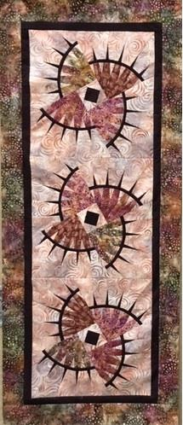

Pattern: Quiltworx Judy Niemeyer Rocky Mountain Bear Claw Pattern with papers

Fabrics:
2 yards background fabric (light)
¼ yard each of four fabrics for the paws (medium dark)
¾ yard of accent fabric for claws, arch and center square (dark)
¼ yard inner border (can be the same as accent, claws, and arch)
1 yard for outer borders and binding
The fabric yardage and papers in the pattern are for 4 blocks. Table runner image shows 3 blocks.

Class Supplies:
Sewing machine in good working order
Open toe sewing foot
¼” foot
Rotary Cutter (mats will be available for use in class)
6 ½” by 12 ½” ruler
Needles Size 70
12” Add-a-Quarter Ruler (6” will also be useful)
Glue Stick (washable)
Fabric Glue Pen (Fons & Poter or Sewline)
High quality cotton thread in neutral color.
Fine Quilting pins
Quilt clips
3 Large Ziploc bags

Things to do before class:
Press fabrics to remove harsh creases.
Cutting to be done before class:

Background fabric
4 strips 4 ½” x WOF (Width of fabric)
8 strips 5 ½” x WOF
1 strip 2 ½” x WOF
4 Different Accent Paw Fabrics
1 strip 6 ½” x WOF of each fabric
Accent Claws
3 strips 4” x WOF
Accent/Background Arch
2 strips 4 ½ x WOF
Accent Square
4 pieces 3 ½” x 3 ½”

Questions: contact Rose Mary rmpsew@hotmail.com

