**Sew Much More**

**2140 W St Paul Ave**

**Waukesha 262-547-7774**

**Supply List for Tamarack Jacket**

Amy Wierkiewicz

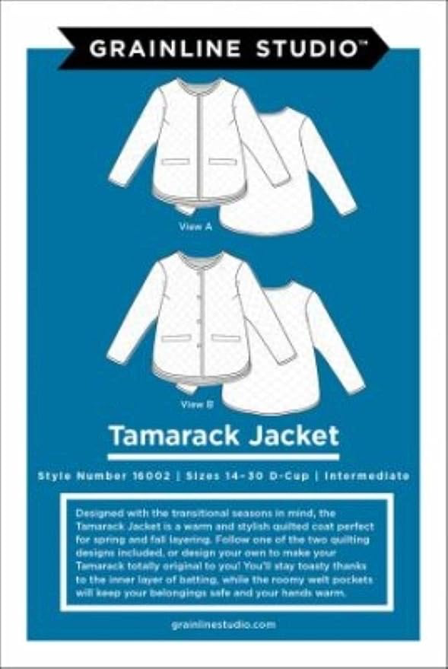Jan. 21, Feb. 11 and Feb. 25, 10am – 2pm

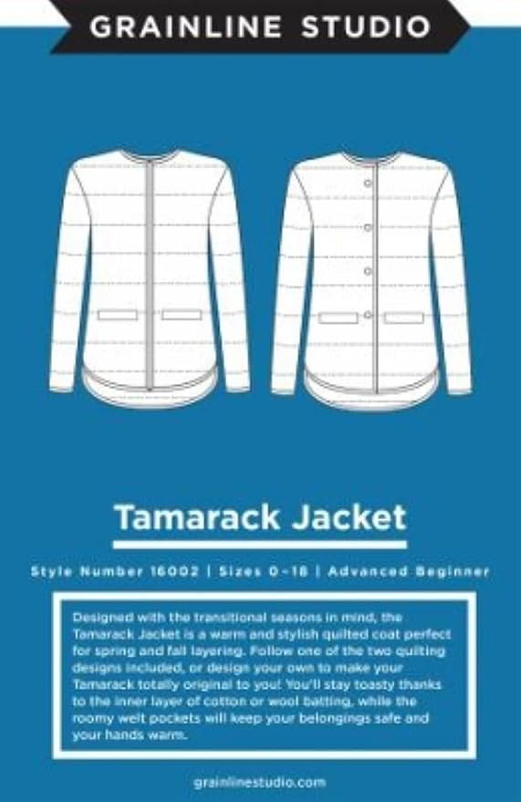

**Supplies needed for the First Session:**

Grainline Studio Tamarack Jack pattern in your size

Optional: Hood, Collar and Pocket Variation available on Grainline’s website

Pattern trace – 2-3 yards

Muslin– 2-3 yards

**Basic Sewing Supplies** (Pins, needles, scissors, rotary cutter, thread, seam ripper, rulers, tape measure, washable marking pen, seam gauge)

**Sewing Machine** in good working order. Always a good idea to clean, oil, put a new needle in before class. Bring the manual for the machine if you are not familiar with all aspects of the machine.

# Class Policies

* Classes require a minimum of 4 students. If the minimum is not reached 2 weeks before class, it will be cancelled and students will receive a full refund.
* If you have registered for a class and must cancel, please contact us ASAP. You must cancel at least two (2) weeks in advance to receive a refund or credit. No credit for no-shows.
* In deference to those with sensitivities, we ask that you refrain from wearing perfume or other scented products
* We would appreciate it if you purchase your supplies at Sew Much More. We will be happy to assist you in gathering all the necessary materials – and give you a 15% discount!