
Sew Much More
2140 W St Paul Ave
Waukesha 262-547-7774
Supply List for Paper Pieced Tulips
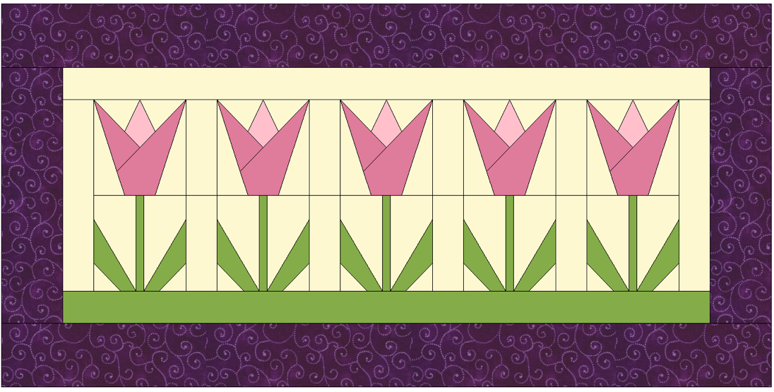
Wendy Kleman

12” by 24”

Supplies for Class
Pattern is designed and provided by Wendy

Fabric:
A light and medium fat quarter for the tulips. ½ yd for background
¼ yard of green for stems and bottom first border
¼ yd for outer border

Sewing machine in good working order
Machine needles (this is foundation pieced and needles may dull fast)
Glass head straight pins or heat resistant pins are great
Rotary cutter with sharp blade
Add a Quarter Ruler-if you have the cardboard insert keep it-if not bring a 12” piece of template plastic
Glue stick
Piecing thread (I prefer Aurifil)
¼ inch foot and zigzag foot
Seam ripper, small sharp point scissors, large scissors
Recommended but not required a travel size iron

Basic Sewing Supplies (Pins, needles, scissors, rotary cutter, thread, seam ripper, rulers
Sewing Machine in good working order. Always a good idea to clean, oil, put a new needle in before class. Bring the manual for the machine if you are not familiar with all aspects of the machine.

The classroom has large cutting mats, irons and ironing boards if you do not want to bring your own. You will also have access to an ironing press to make your quilt sandwiches

If you have any questions about the class or what to bring please contact Wendy Kleman at the store: 262-547-7774

Class Policies
- Classes require a minimum of 4 students. If the minimum is not reached 2 weeks before class, it will be cancelled and students will receive a full refund.
- If you have registered for a class and must cancel, please contact us ASAP. You must cancel at least two (2) weeks in advance to receive a refund or credit. No credit for no-shows.
- In deference to those with sensitivities, we ask that you refrain from wearing perfume or other scented products
- We would appreciate it if you purchase your supplies at Sew Much More. We will be happy to assist you in gathering all the necessary materials – and give you a 15% discount!

