**Sew Much More**

**2140 W St Paul Ave**

**Waukesha 262-547-7774**

**Supply List for Shirt Jacket**

Sue Timmons

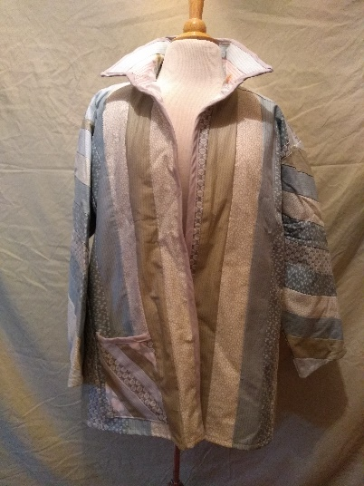

**Supplies for Class**

* Ready-made long sleeve, washable man-styled shirt ***2-3 sizes larger*** than usual size. ***(No pleats in shirt back – NOT a fitted man’s shirt – Straight sides seams)***
* 5 - ½ yds. 42-45” wide washable cotton fabric or 1- 40 ct jelly roll
* 18” x 22” piece (fat quarter) of washable cotton for pocket(s)
* ½ yds. of contrasting fabric for binding, trim
* Seam ripper or seam ripper knife
* Coordinating thread
* Fabric temporary adhesive spray
* Rotary cutter and cutting mat
* Scissors, pins and clips
* 24” Ruler
* 60 degree ruler
* Marking pen/pencil/chalk
* Sewing machine **with manual** and supplies

***Decisions prior to purchase:***

* *Length of jacket?* 
  + *Suggest: back length of 24”-27” after hemming or measure a favorite jacket to use as guide.*
* *How many fabrics?* 
  + *Suggest: At least 4-5 for different fabric strips for jacket and a contrasting fabric for binding.*
* *Length of sleeves? Long or ¾ length sleeves?*
  + *Suggest: Measure from underarm to wrist or use a favorite jacket to use as guide. Make sure shirt sleeves are length desired* ***after*** *cuff removed.*

**Basic Sewing Supplies** (Pins, needles, scissors, rotary cutter, thread, seam ripper, rulers

**Sewing Machine** in good working order. Always a good idea to clean, oil, put a new needle in before class. Bring the manual for the machine if you are not familiar with all aspects of the machine.

The classroom has large cutting mats, irons and ironing boards if you do not want to bring your own. For an all day class you might want to pack a lunch *(Aldi and Le Gong restaurant are in our strip mall as an alternative)*

If you have any questions about the class or what to bring please contact Sue Timmons @ 262-547-3726

# Class Policies

* Classes require a minimum of 4 students. If the minimum is not reached 2 weeks before class, it will be cancelled and students will receive a full refund.
* If you have registered for a class and must cancel, please contact us ASAP. You must cancel at least two (2) weeks in advance to receive a refund or credit. No credit for no-shows.
* In deference to those with sensitivities, we ask that you refrain from wearing perfume or other scented products
* We would appreciate it if you purchase your supplies at Sew Much More. We will be happy to assist you in gathering all the necessary materials – and give you a 15% discount!