**Sew Much More**

**2140 W St Paul Ave**

**Waukesha 262-547-7774**

**Supply List for SERGER-TUCKED THROW**

Sue Timmons

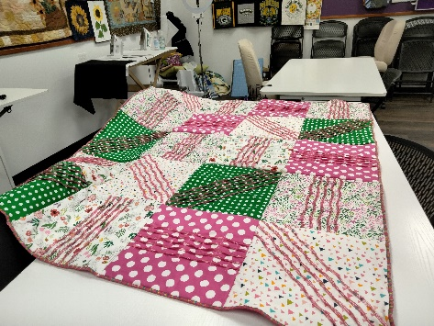

**Supplies for Class**

* 5 – 45” - or 60”- width fabrics, such as satin, taffeta, velvet, velveteen or flannel. (Stretchy fabric not recommended)
* Fabrics 2 & 3 are cut out on the diagonal; directional fabric not recommended.
  + Fabric 1: ½ yd. of 45”-wide or ½ yd. of 60”-wide for 2 squares
  + Fabric 2: 1 ¼ yds. of 45”-wide or 2/3 yd. of 60”-wide for 3 squares
  + Fabric 3: 1 ¼ yds. of 45”-wide or 1-1/8 yds. of 60”-wide for 4 squares
  + Fabric 4: 1 ¼ yds. of 45”-wide or 7/8 yd. of 60”-wide for 5 squares
  + Fabric 5: 1 ¼ yds. of 45”-wide or 7/8 yd. of 60”-wide for 6 squares
* Backing fabric: 3 1/8 yds. of 45”-wide or 2 yds. of 60”-wide coordinating fabric or can use one of the five fabrics used in the quilt top.
* Batting: 52” x 65” rectangle or 4 yds. of 40”-wide with ¼ “ loft
* 2 cones/spools of decorative thread for upper and lower loopers for each fabric color desired and 1 cone serger thread for needle to match each fabric color desired. (I used 2 different colors of Maxi-Lock Stretch in both loopers & a matching color cone of serger thread)
* 4 cones serger coordinating thread to serge throw together
* Fray check
* Rotary cutter and cutting mat
* Scissors, pins
* Size 12 & 14 serger needles
* 24” & 36” Ruler
* Turning tool (bodkin, chopstick)
* Marking pen/pencil/chalk
* Serger **with manual** and supplies

**Prior to Class *cut out* the following:**

**Cutting Directions:**

**Fabric:** Brings the 5 different fabric yardage to class UNCUT. The quilt squares will be cut after serging the tucks

**Backing fabric:** Cut 5 - 50” x 13” rectangles.

**Batting:** Cut 20 - 13” squares

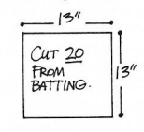 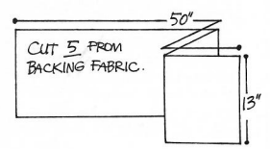

**Basic Sewing Supplies** (Pins, needles, scissors, rotary cutter, thread, seam ripper, rulers

**Sewing Machine** in good working order. Always a good idea to clean, oil, put a new needle in before class. Bring the manual for the machine if you are not familiar with all aspects of the machine.

The classroom has large cutting mats, irons and ironing boards if you do not want to bring your own. For an all day class you might want to pack a lunch *(Aldi and Le Gong restaurant are in our strip mall as an alternative)*

If you have any questions about the class or what to bring please contact Sue Timmons @ 262-547-3726.

# Class Policies

* Classes require a minimum of 4 students. If the minimum is not reached 2 weeks before class, it will be cancelled and students will receive a full refund.
* If you have registered for a class and must cancel, please contact us ASAP. You must cancel at least two (2) weeks in advance to receive a refund or credit. No credit for no-shows.
* In deference to those with sensitivities, we ask that you refrain from wearing perfume or other scented products
* We would appreciate it if you purchase your supplies at Sew Much More. We will be happy to assist you in gathering all the necessary materials – and give you a 15% discount!