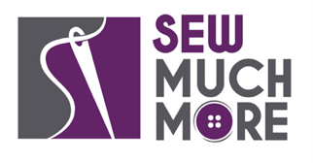
Sew Much More
2140 W St Paul Ave
Waukesha 262-547-7774
Supply List for Bucket Hat
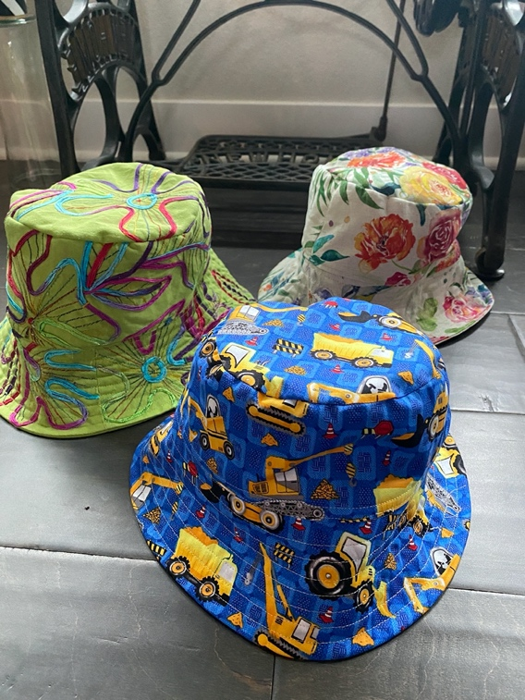

Wendy Kleman

A bucket hat is easy to make. I will have the pattern in class and you can make copies of it in multiple sizes from baby to adult. Come knowing the head size you want to fit. Measure from top of eyebrows, to the top of ears and around. They are reversible.

Supplies for Class
1/3 yard in two colors of cotton, canvas, lightweight denim or Essex Linen
All purpose thread
A wound bobbin that matches
SF101 fusible woven interfacing for the brim 1/2 yd of 22” wide
Thread snips or scissors
Pattern Ease to make copies of the pattern in your desired size

Sewing Machine in good working order. Always a good idea to clean, and oil. Bring the manual for the machine if you are not familiar with all aspects of the machine.

If you have any questions about the class or what to bring please contact Wendy Rieves, Wendy@sewmuchmorewi.com, 262-547-7774

Class Policies
- Classes require a minimum of 4 students. If the minimum is not reached 2 weeks before class, it will be cancelled and students will receive a full refund.
- If you have registered for a class and must cancel, please contact us ASAP. You must cancel at least two (2) weeks in advance to receive a refund or credit. No credit for no-shows.
- In deference to those with sensitivities, we ask that you refrain from wearing perfume or other scented products
- We would appreciate it if you purchase your supplies at Sew Much More. We will be happy to assist you in gathering all the necessary materials – and give you a 15% discount!

