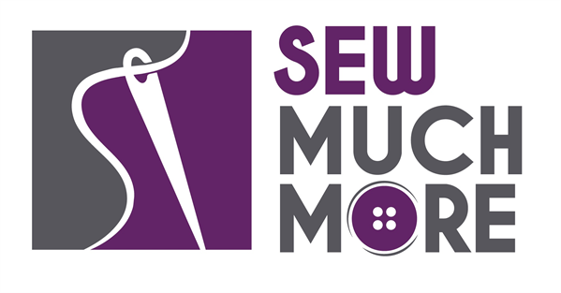
Sew Much More
2140 W St Paul Ave
Waukesha 262-547-7774
Supply List for SERGER TEXTURED PILLOW
Sue Timmons

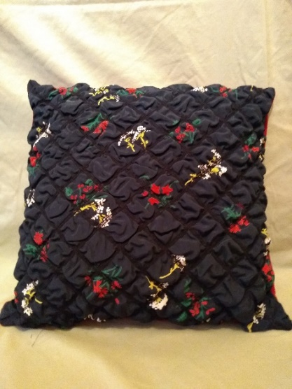

Supplies for Class:
- ½ yd. fabric (light weight)
- 18” x 18” Bosal Stitch & Steam
- Lightweight batting (Optional)
- Fiberfill (pillow filling) or 14” pillow form
- Temporary spray adhesive
- 4 cones coordinating/decorative thread
- Rotary cutter and cutting mat
- New serger machine needles
- Scissors, pins
- 24” Ruler
- Turning tool (bodkin, chopstick)
- Marking pen/pencil/chalk
- Serger with manual and supplies
- Clear Serger foot (preferred) or standard serger foot
- Serger cover/chain stitch Table with guide fixing screws for table. Looks like this 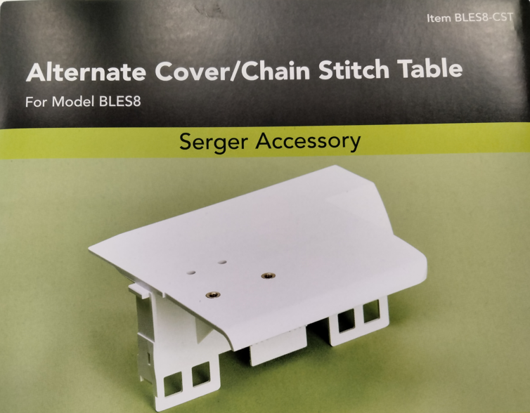 or this 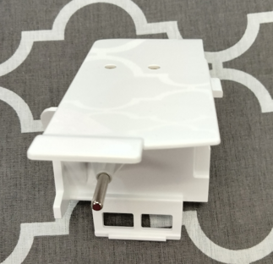

Basic Sewing Supplies (Pins, needles, scissors, rotary cutter, thread, seam ripper, rulers

Serger Machine in good working order. Always a good idea to clean, oil, put a new needle in before class. Bring the manual for the machine if you are not familiar with all aspects of the machine.

The classroom has large cutting mats, irons and ironing boards if you do not want to bring your own. For an all day class you might want to pack a lunch (Aldi and Le Gong restaurant are in our strip mall as an alternative)

If you have any questions about the class or what to bring please contact the teacher through the store. 262-547-7774

Class Policies
- Classes require a minimum of 4 students. If the minimum is not reached 2 weeks before class, it will be cancelled and students will receive a full refund.
- If you have registered for a class and must cancel, please contact us ASAP. You must cancel at least two (2) weeks in advance to receive a refund or credit. No credit for no-shows.
- In deference to those with sensitivities, we ask that you refrain from wearing perfume or other scented products
- We would appreciate it if you purchase your supplies at Sew Much More. We will be happy to assist you in gathering all the necessary materials – and give you a 15% discount!

