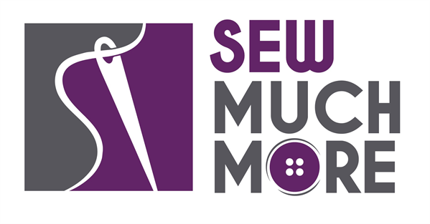
Sew Much More
2140 W St Paul Ave
Waukesha 262-547-7774
Supply List for Chenille Potholder
Sue Timmons

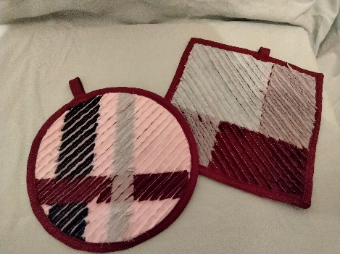

Supplies for Class
These potholders are super simple and fun to sew. Just layer, stitch and cut. Make them round or square: You decide. A great gift idea.

Supply List:

(Note: You don’t have to have the exact colors listed below, just make sure to have white fabric and three other colors)
- Fabric: (Fat quarters are 18” x 21”. Fat eights are 9” x 21”)
  - White 1 fat quarter (Must color)
  - Red 1 fat quarter
  - Lime 1 fat eighth
  - Dark 1 strip 2” X 20”
- 1/3 yard (22”wide) Insul-Bright makes two potholders
- 1 pkg Matching extra-wide bias tape

Tip: Fabrics that look the same on both sides such as solids or batiks will have strong colors. Fabrics that are white or light on the back will have softer colors. Print motifs will soften and blur

- Any color thread
- Sewing machine (walking foot recommended) and related supplies
- Rotary cutter, mat and ruler
- Chenille Cutter or sharp pointy Scissors
- Washable marking pen, pencil or chalk
- Round cutting grid (optional) (use to cut round potholder)

Basic Sewing Supplies (Pins, needles, scissors, rotary cutter, thread, seam ripper, rulers
Sewing Machine in good working order. Always a good idea to clean, oil, put a new needle in before class. Bring the manual for the machine if you are not familiar with all aspects of the machine.

The classroom has large cutting mats, irons and ironing boards if you do not want to bring your own. For an all day class you might want to pack a lunch (Aldi and Le Gong restaurant are in our strip mall as an alternative)

If you have any questions about the class or what to bring please contact Sew Much More 262-547-7774

Class Policies
- Classes require a minimum of 4 students. If the minimum is not reached 2 weeks before class, it will be cancelled and students will receive a full refund.
- If you have registered for a class and must cancel, please contact us ASAP. You must cancel at least two (2) weeks in advance to receive a refund or credit. No credit for no-shows.
- In deference to those with sensitivities, we ask that you refrain from wearing perfume or other scented products
- We would appreciate it if you purchase your supplies at Sew Much More. We will be happy to assist you in gathering all the necessary materials – and give you a 15% discount!

