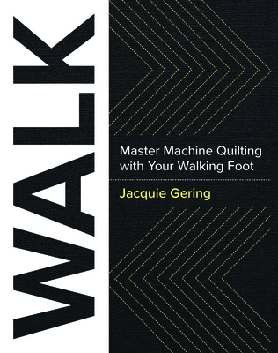
Walk this Way
Wendy Kleman
2022

Supplies
- 4, 20” square cotton quilt sandwiches of a light solid color (Hobbs Fusible batting recommended)
- Walking foot
- Sewing machine in good working order with a new Microtex needle and several filled bobbin
- Frixion Pen
- Aurifil thread in a medium to dark color. Grey is always a good choice
- 12 ½” quilting ruler
- The WALK book

