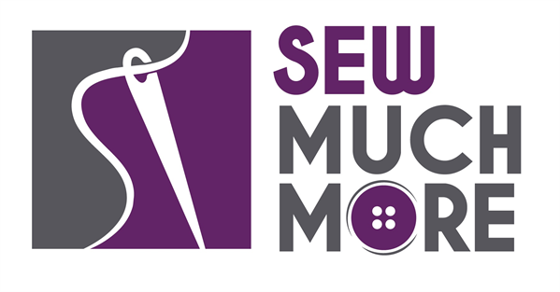
Sew Much More
2140 W St Paul Ave
Waukesha 262-547-7774
Supply List for Iron Caddy Tote
Sue Timmons
Tuesday, 6/15/22 @ 9:30 am – 1:30 pm
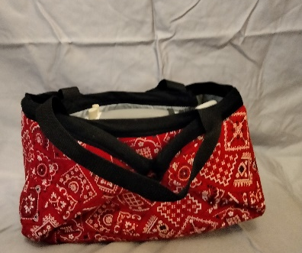

Supplies for Class
- Fabric:
* 5/8 yd. Main Fabric
* 5/8 yd. Insul-bright
* 5/8 yd. Silver Iron Board Fabric
* 1 ¼ yds. Warm & Natural Batting
- ¼ yd. Contrast fabric for straps –OR 36” x 1” coordinating webbing
- 5/8 yds. Contrast fabric for binding OR 1 yd. if using contract fabric for straps & binding. (You will need for binding about 91” with ease/overlap which is 5/8 yds. of fabric.) Recommend cutting it on the bias (you will have to piece it together), and cutting it 4” wide.
- 2 pieces of the batting – 1”x 33” for fabric straps (Omit if using webbing for straps)
- 8” of ¼” wide Elastic – You can also use a 2 colored hair elastic for a much prettier effect
- 2 pretty buttons (or use Chinese frog or hook and eye closures instead of the buttons and elastic)
- Heat Erase pen – Frixion or other brand
- Rotary cutter and cutting mat
- Scissors, pins
- 24” Ruler
- Turning tool (bodkin, chopstick)
- Sewing machine and supplies (Walking foot or Rolling foot recommended, but optional)

Basic Sewing Supplies (Pins, needles, scissors, rotary cutter, thread, seam ripper, rulers
Sewing Machine in good working order. Always a good idea to clean, oil, put a new needle in before class. Bring the manual for the machine if you are not familiar with all aspects of the machine.

The classroom has large cutting mats, irons and ironing boards if you do not want to bring your own. For an all day class you might want to pack a lunch (Aldi and Le Gong restaurant are in our strip mall as an alternative)

If you have any questions about the class or what to bring please contact Sue Timmons @ itsastitch@sbcglobal.net

Class Policies
- Classes require a minimum of 4 students. If the minimum is not reached 2 weeks before class, it will be cancelled and students will receive a full refund.
- If you have registered for a class and must cancel, please contact us ASAP. You must cancel at least two (2) weeks in advance to receive a refund or credit. No credit for no-shows.
- In deference to those with sensitivities, we ask that you refrain from wearing perfume or other scented products
- We would appreciate it if you purchase your supplies at Sew Much More. We will be happy to assist you in gathering all the necessary materials – and give you a 15% discount!

